PROPOSAL

FOR A TRAINING COURSE

Sollefteå Sweden
11th August until the 19nd of August 2009, Sollefteå, Sweden
We are urgently looking for partners according to the project conditions for the deadline of 1st FEBRUARY 2009
IDEA
With this training we want to train youth workers and youth leaders from both Europe and the partner countries to cope with, use and predict conflict situations in the work they do and the organisations they work in, closely related to the management of their organisations and the management of their activities/ projects.
Participants
4 youthleaders / youthworkers / youngsters per country
Countries:
Member States of the European Union (EU)
Austria  Belgium  Bulgaria  Cyprus  Czech Republic  Denmark  Estonia  Finland  France | Germany  Greece  Hungary  Ireland  Italy  Latvia  Lithuania  Luxembourg  Malta | Netherlands  Poland  Portugal  Romania  Slovak Republic  Slovenia  Spain  Sweden  United Kingdom

Programme Countries of the European Free Trade Association (EFTA)
which are members of the European Economic Area (EEA)
Iceland | Liechtenstein | Norway

Programme Countries which are candidates
for accession to the European Union
Turkey

Neighbouring Partner Countries
The Youth in Action Programme supports cooperation between Programme Countries and the following Neighbouring Partner Countries:
astern Europe and Caucasus
Armenia
Azerbaijan
Belarus
Georgia
Moldova
Russian Federation
Ukraine

Believing in equal opportunities, Sollefteå municipality respects gender balance between males and females.
In principle, contact persons are reminded that their respective delegations should be people aged between 18 and …. Until 100 ☺ age. Should you have a problem in selecting participants please inform us.

Participation fee:
EU countries 20 Euro per person
30% of your travel costs from your home to here.

Venue
Sollefteå Sweden www.solleftea.se

Dates
Travel day 11th August and 19nd of August 2009, Sollefteå, Sweden

Programme of Activities
We are providing you with a program of activities. We ask you to make this available to the delegate/s attending the event. Delegates are expected to be present for all sessions and those not present will forfeit reimbursement.
The draft programme is attached.

Deadline
To sent the PartIII agreement until 05th january 2009 only by original
Post it to following adress
Ungdomsenheten (Tony Vieira)
KUFF Sollefteå Sweden
SE Sollefteå SWEDEN

Sent us 2 copies of original signet PartIII agreement,
we not accept agreements by fax, or email.

Trainers
This project is administrated by Youth Unit, Culture Education and Sports administration at Sollefteå municipality.
The trainers will be hold by The Knot in Brussels Belgium
for more information look into here: http://www.theknotweb.net

Food and Beverages
Since delegates will stay on a Full Board basis and Half Board Basis, all meals shall be covered by the hosts. However, in the case of beverages (both alcoholic and non-alcoholic) delegates are expected to purchase their own. Therefore we recommend that participants have some money available.

Dietary / Health Conditions
If you have any particular dietary restrictions or suffer serious health conditions or allergies, kindly indicate this in the registration form.

PRACTICALITIES

Travel
Reimbursement of Travel

Travel expenses are 70% reimbursed (on presentation of the relevant receipts) if you travel in the cheapest way, The payment will be made by bank transfer, NOTE! no cash reimbursement only by bank transfer.
Upon arrival in Sollefteå participants shall be able to photocopy their travel tickets but we want you to photocopy them already in your country before using in the travel so we have the full copy of the original ticket and official receipts (2 copies). Once proof of travel cost is collected and the hosts will reimburse 70% of the total travel cost.

Observe that the reimbursement will only be made 1 week after the training course.
If you have all documents in order, receipts, invoices, we will give you the money already during the training course (note! -last 2 days)

Any other expenses as for the visa application should also be handed on the arrival day at the hotel.

- Together with the preliminary agreement Part III, we also need to know your whole estimated draft travel expenses and the name of the city that you travel including the mean of transport(train, car, bus, plane).
- Participants are expected in Sollefteå by 11st august 2009 and depart the following 19st august 2009. This means that participants are hosted for 7 nights and that contact persons are to book participants’ travel tickets on these dates early to avoid full flights. The travel tickets booked should be notified to us as soon as possible and registered on the delegates registration form (will be sent to you after aproval of the project).

- When you get a offer of the travel flight are recommended as they are the cheapest you shall contact the project coordinator to check if the price is reasonable and if maybe in Sweden we can buy cheaper flights.

Accommodation
Participants will be accommodated at no charge for a maximum of 7 nights on full board basis (breakfast, lunch and dinner) at the youth hostal.

Delegates will be accommodated 2 to 4 persons in a room and thus each delegate will be sharing the room. We shall however do our outmost to try to satisfy all your accommodation demands.

Extra Nights
Whilst air companies operates daily flights to a number of destinations, some other destinations only receive flights directly to Sweden once or twice a week. This might encourage participants to stay for extra days.

- Also participants may be interested in discovering the Sweden and stay. We are therefore encouraging participants to stay for extra days in Sollefteå Sweden and have made arrangements by themselves. The extra nights are going to be paid by the participants.
- If the above reasoning if not satisfactory. You may also search other hotels listed online in internet.

Transfers
Transfers from the airport to youth hostel shall be organized by the hosts and this is why indication of arrival time / flight number is required on the delegates registration form.

Insurance
Participants are required to be in possession of a travel insurance policy, since this will not be covered by the hosts. Whilst organizing the event with utmost diligence, the hosts are nonetheless relieved of any obligation or responsibility arising from death, personal injury, illness, theft or any other misfortunate circumstance. Participants are to indicate insurance cover in the delegates registration form, and encouraged to effect such insurance policy as precaution is better than cure!

Currency
www.forex.se
Swedich Kroan 1 Euro = 9 kronor

Meetings / Workshops
All plenary meetings / workshops will take place in the empty room Hall. Workshops are going to be held within the different conference rooms that the youth hostal corporate, some of the workshops will be outdoors.
Look here: http://www.solleftealarcenter.se/about/premises.html

Evening Entertainment
Evening entertainment
We will select a social Entertainment committee (participants themselves)
So prepare to organize yourself a Party ☺

Weather Conditions
The temperature in Sweden at this time of year is still not so hot.
You may check latest weather conditions on internet.
In august is light almost 20 hours a day, the sun is upp over at least 15 hours a day.
The medium temperature is +15 degrees outside.

Working Language
Delegates should also be conversant in English, since all plenaries, presentations, workshops, games and meetings will be delivered in this language. Participants shall speak GOOD english.

To bring with you
We kindly ask participants for bringing materials about their organisations
- Some discs with the national music
- Inform. materials for multimedia presentation
- Flags of your countries
- Comfortable shoes for sport games both inside and outside
- Comfortable clothes for sport, SKI and snow
- a swimming suit
- a big towel for a sauna and Swimming
- Shampoo, soap, tooth paste and brash, etc.
- Individual specific medicines (if it’s really necessary, we have only standard set of medicines)
- Warm sweater
- Something typical from your town, region or country – music, food or drinks☺ – to share with other participants during the intercultural evening will be welcomed!! And of course don’t forget about lots of energy, enthusiasm and curiosity!!
Big smile!
For the exhibition you are asked to bring with you everything you think may be useful to present your organisation and promote your activities and projects, such as leaflets, brochures, videos, slides, etc.

WHAT TO DO NEXT:
- Send us the preliminary agreement Part III
- Send us your travel costs in Euro
- Send us the meaning of transport including name of cities

Special requirements
- When you have some special requirements including food (vegetarian, etc.), please do not hesitate to write to Mr. TONY VIEIRA email: tony@solleftea.se

Practicalities contacts:
For all the practical information about the meeting sent
Email. tony@solleftea.se
Or contact Mr. Tony Vieira
Youth Coordinator
Youth site. http://ungdom.solleftea.se/samordnare.htm
Phone office hours 07.00 am – 16.30 pm. +46 620 68 23 12
Cellular. +46 703 46 18 92
Fax. +46 620 68 21 97

Looking forward to host you in Sollefteå!
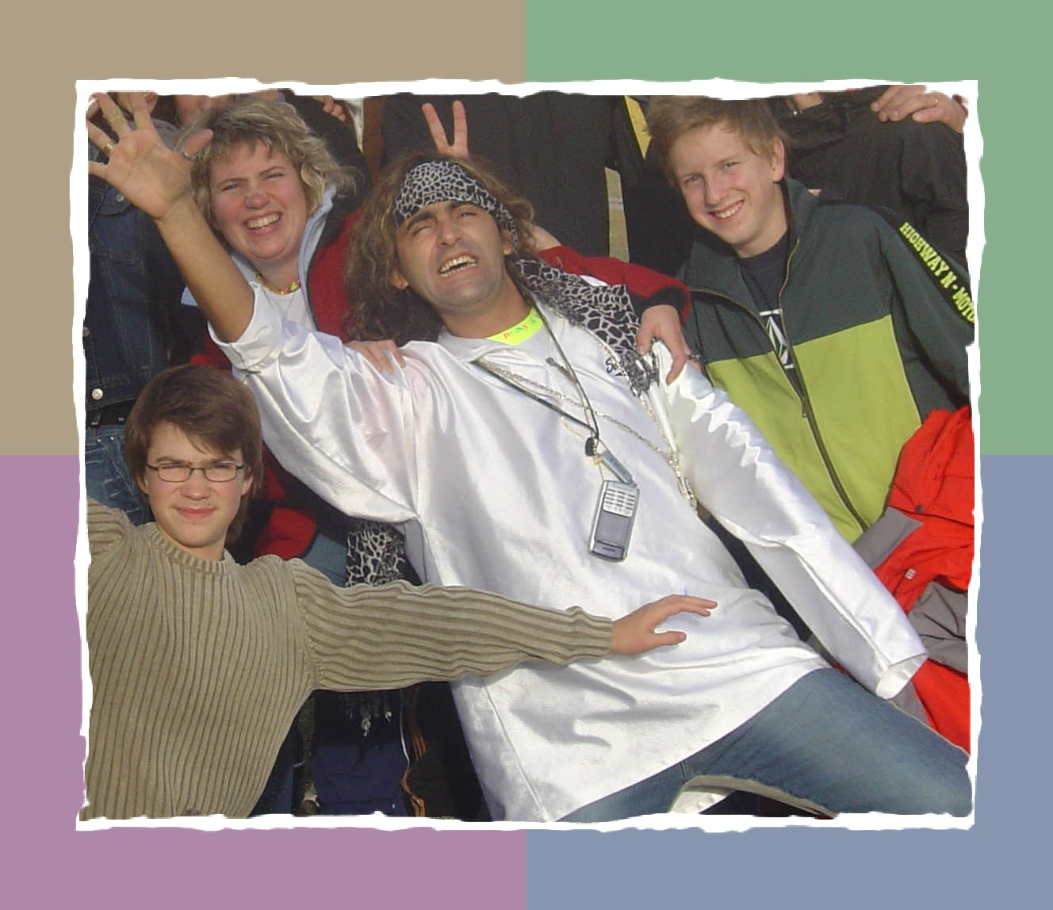
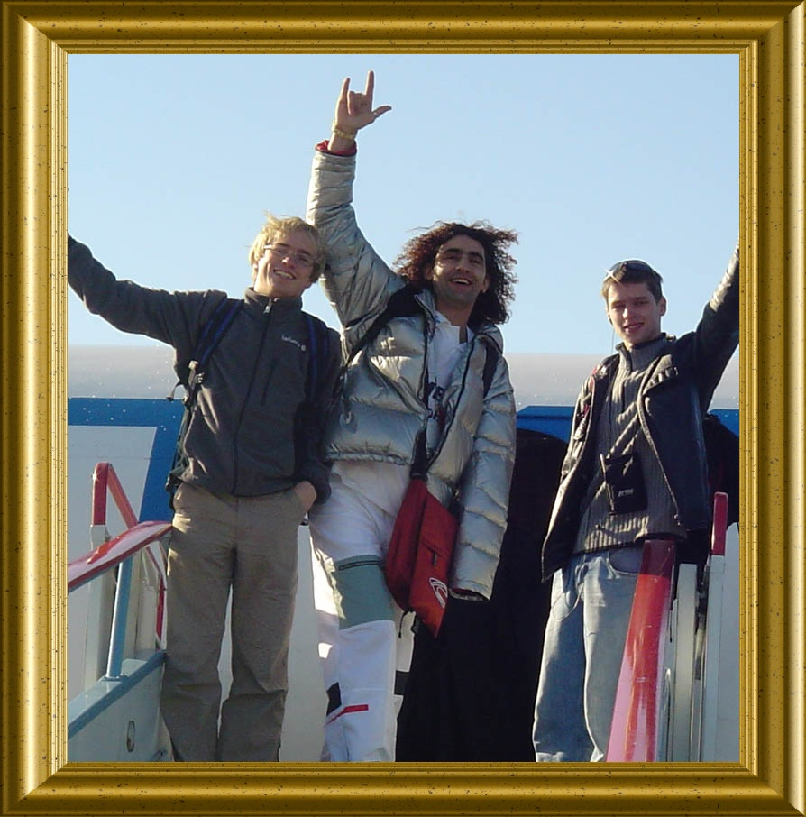
Tony Vieira / Coordinator and Trainer

